// Function to generate EEG data for Delta waves

double Source::generateDelta(double x, double hOff)

{

// the following are all trial and error from viewing waves on Desmos

double a1 = 1.4;

double b1 = 1.4;

double a2 = 0.4;

double b2 = 1.0;

double c2 = 2.3;

double a3 = -1.1;

double mainWave = a1*sin(b1*x-hOff) + a2*sin(b2*x+c2*x) + a3*sin(x);

return D_HZ*mainWave; // modify the height of the wave by Delta frequency average

}

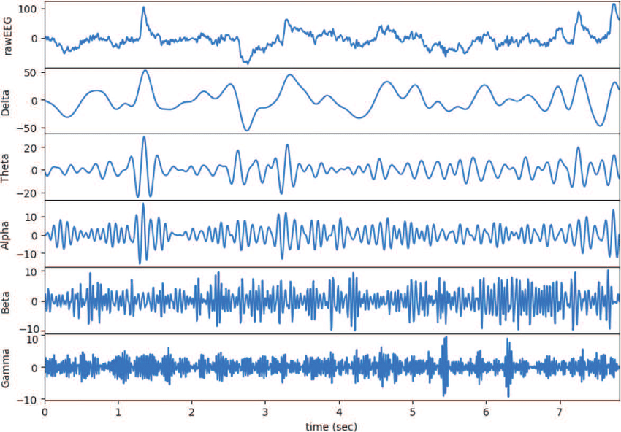

Lect 20

Know exactly what to do from reading the patent

Lect 22

**If it is not specified in the spec, you are free to interpret things**

ANYTHING THAT WE DECIDE IN TERMS OF WHAT IS REQUIRED FROM THE SOFTWARE,

NOT GOING TO CHANGE SPEC,

Specific scenarios with specific wave forms are the interest

Individual treatment

reality is per electrode point having input and feed back, **simulate this as best you can**

(he will get back to us with how he wants this done)

Input

Per electrode/sensor site?

Input may be one wave input consisting of a sequence of brain waves

OR Input may be all brain waves simultaneously -> he will decide later

Implement Analogue to digital basic conversion

Idea is not to generate the frequency itself, but to generate the wave form

From which you will extract the frequency through analysis

Analysis (baseline)

Cap and 21 electrodes, will be picking up different wave forms, they are not the same,

We must look at them individually after we start the process

Calculating dom freq = most energy over time = Power,

issue of power analysis on the spectrum

Offset

Assuming we processed wave form and **arrived at dominant frequency**,

Add the offset frequency to the baseline frequency to obtain a modified frequency

the one [waveform] that will then feedback to the electrodes

Feedback

*Loop 16 times in one second*

Apply offset to dominant frequency

Return dominant frequency modified (stimulate) 16 times per electrode site

PowerDown

On power down do something gracefully, safely, with a message device is not operable

do not just exit program (simulation)

**Profs Resources**

**Breaks down wave form**

**https://www.medicine.mcgill.ca/physio/vlab/biomed_signals/eeg_n.htm**

<https://main.ochslabs.com/about/>

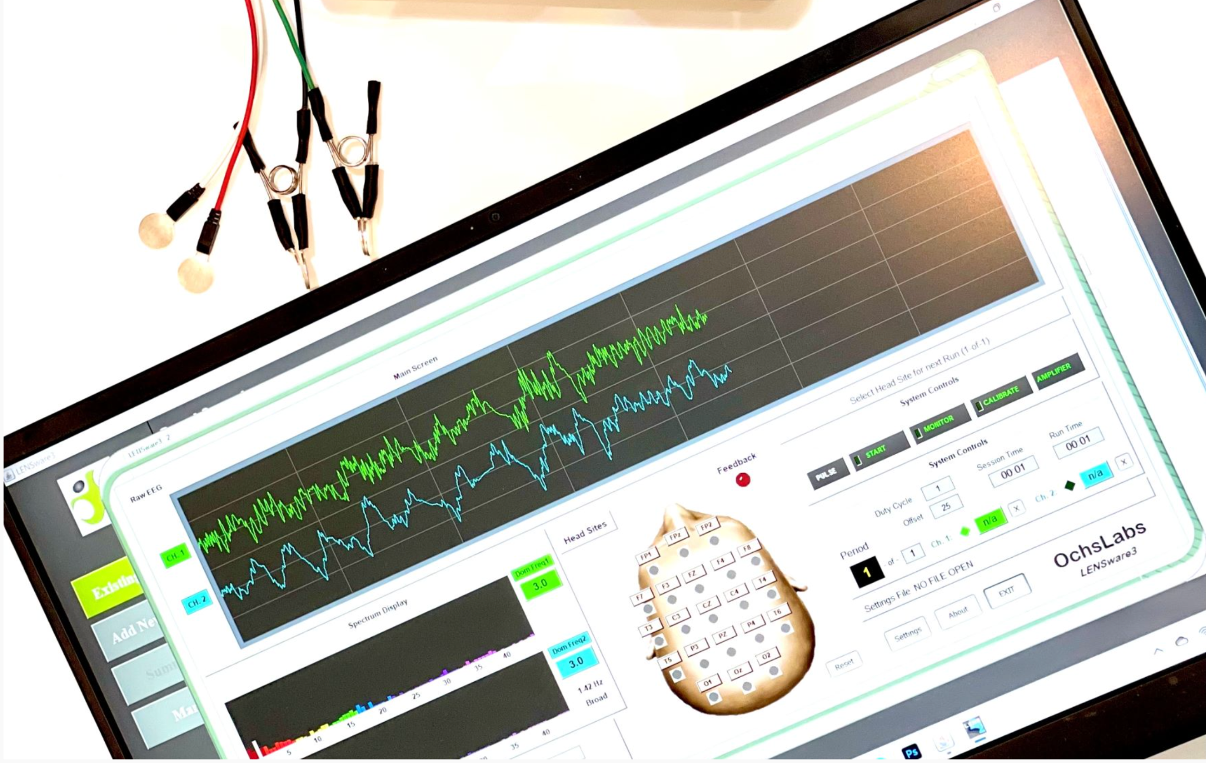

*Only technical information given from source (static image on website)*

I**ntroduction to LENS Neurofeedback**

<https://www.youtube.com/watch?v=kgMPV2eG64Q&t=188s>

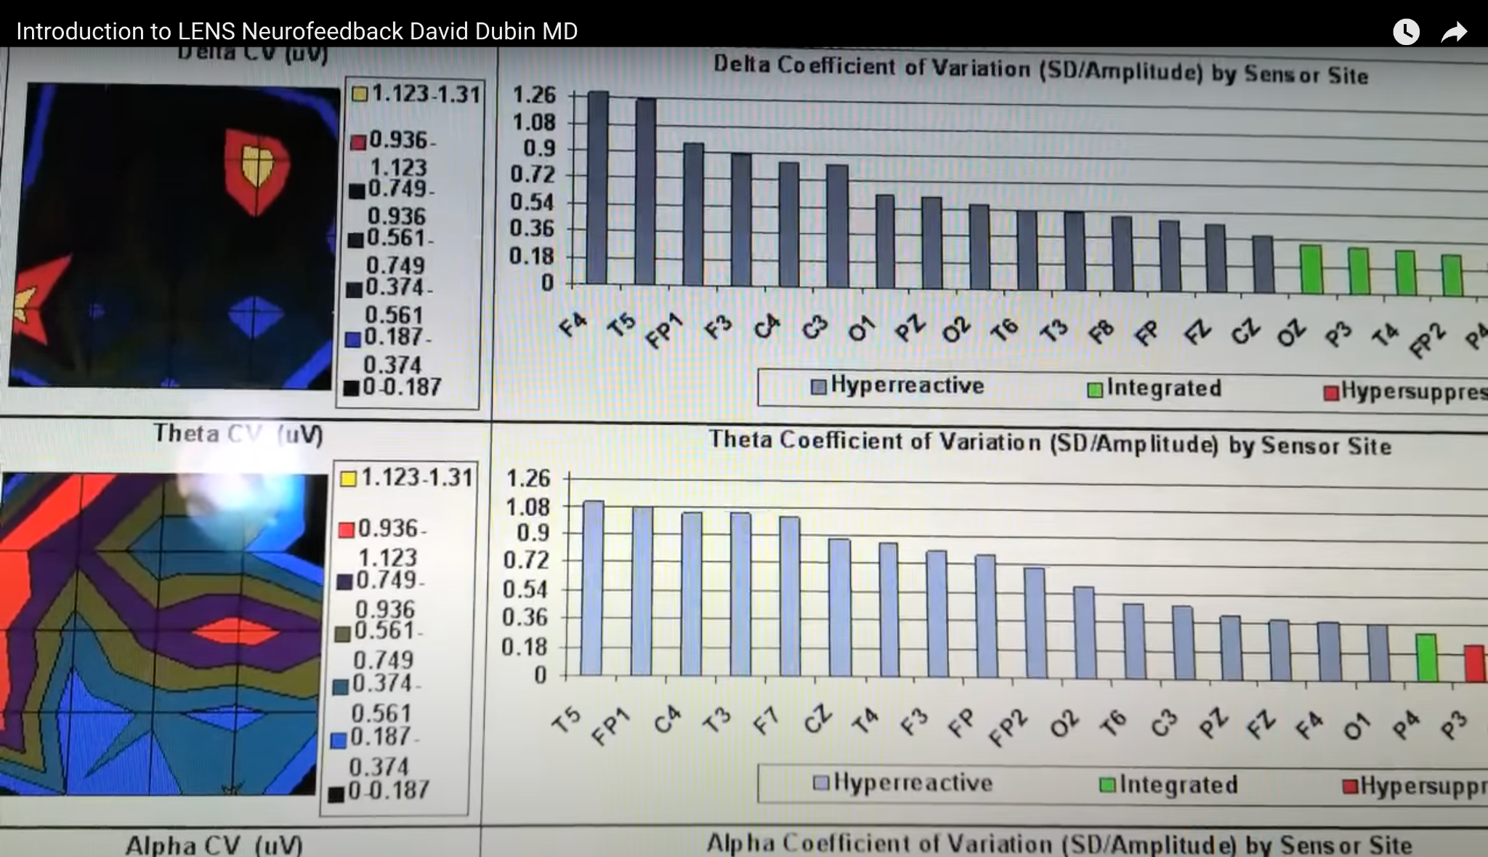

*Only technical information given from source (freeze frame during vid)*

**LENS Neurofeedback vs. Traditional Neurofeedback**

https://www.youtube.com/watch?v=p5jj-jDRF9c

*This is actually bs*

**

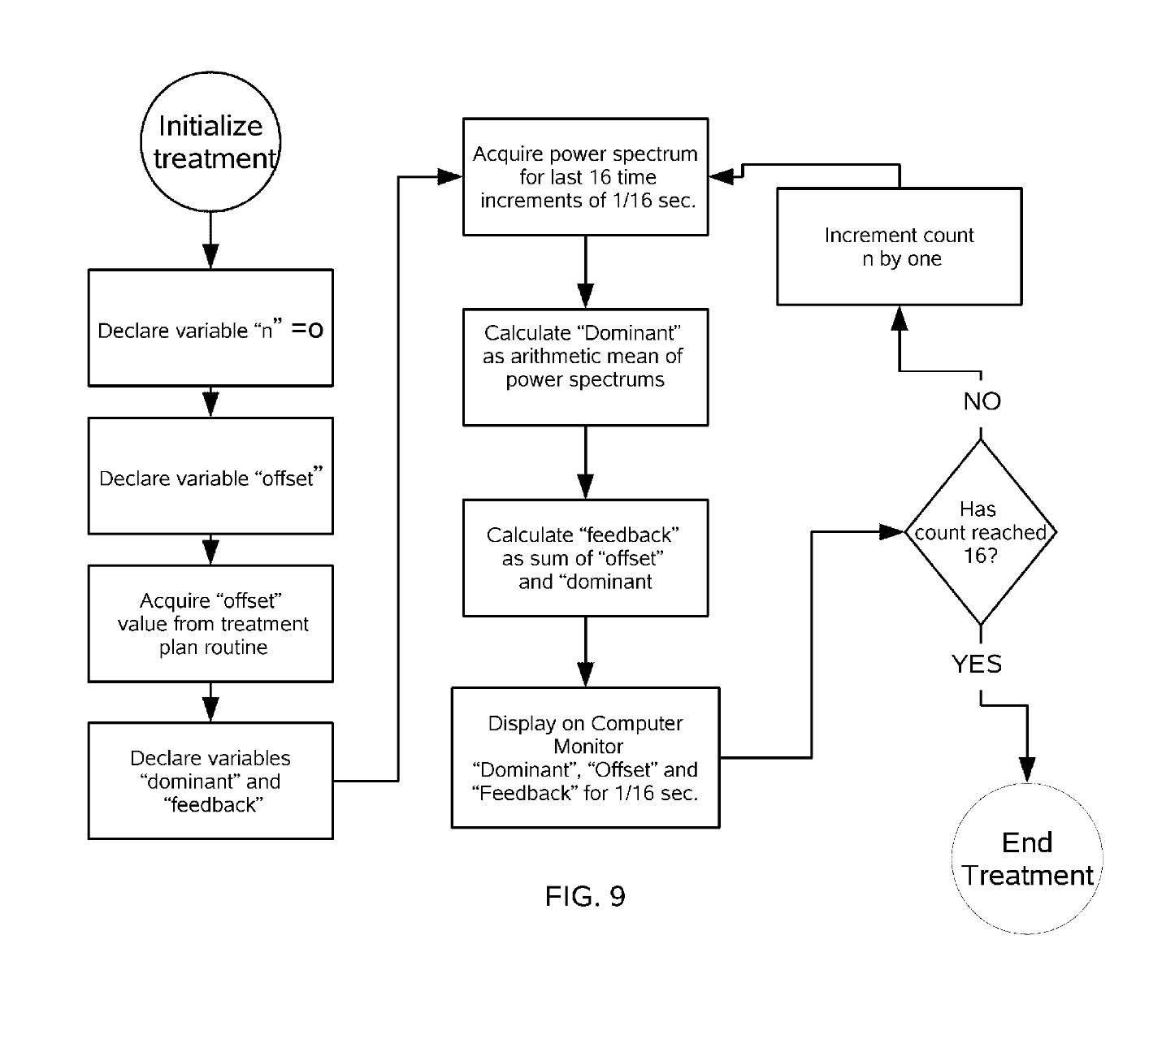

**Patent:**

**More Resources**

**2 min vid explaining EEG**

<https://www.youtube.com/watch?v=tZcKT4l_JZk>

**11 min vid discussing EEG technicals of an EEG test and info on the electrodes**

<https://www.youtube.com/watch?v=T7MKlPYiL48>

**A commercially marketed EEG device for personal consumer**

<https://www.myndlift.com/how-it-works>

https://www.youtube.com/watch?v=7VQCj7_oAao&t=418s

7:00 talks basic info on a EEG measuring device

**A commercially marketed EEG device for research**

<https://www.youtube.com/watch?v=uZL6uQG-t4w>

19-20:00 shows device set up.

35:00+ he shows the brain wave data and discusses how its affected by brain activity

too advanced for average consumer, i think its a product for actual research, but it includes some seemingly useful information to know for designing the simulator

@ 54:00 he talks about bad vs good EEG data and ranges

<https://www.researchgate.net/publication/325701712_Classification_of_human_brain_attention_focused_on_meditation_effected_by_L-theanine_acid_in_Oolong_tea>

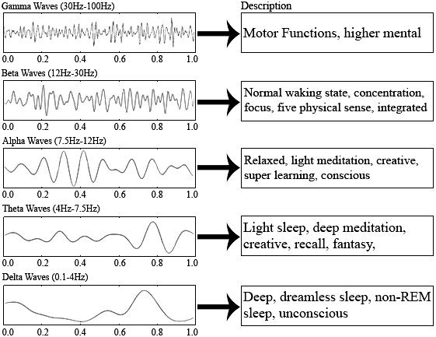

**Simulation of EEG readings of brain waves**

<https://cs.brown.edu/people/epavlick/eeg/eeg.html>

Some equations for simulating brain waves (not confident the credibility, not sure if this is necessary)

x = time

aHz = 10

bHz = 19

dHz = 0

tHz = 0

hOff = ? offset based off mapping of electrodes to background rhythms

**Delta**

0.25*sin(**dHz**\*2*PI*(x+hOff))*((7+Math.random())/10)

**Theta**

0.20*sin(**tHz**\*2*PI*(x+hOff))*((7+Math.random())/10)

**Alpha**

0.15*sin(**aHz**\*2*PI*(x+hOff))*((7+Math.random())/10) - > low

0.18*sin(**aHz**\*2*PI*(x+hOff))*((7+Math.random())/10)

**Beta**

0.05*sin(**bHz**\*2*PI*(x+hOff))*Math.random() -> “low”

0.10*sin(**bHz**\*2*PI*(x+hOff))*Math.random()

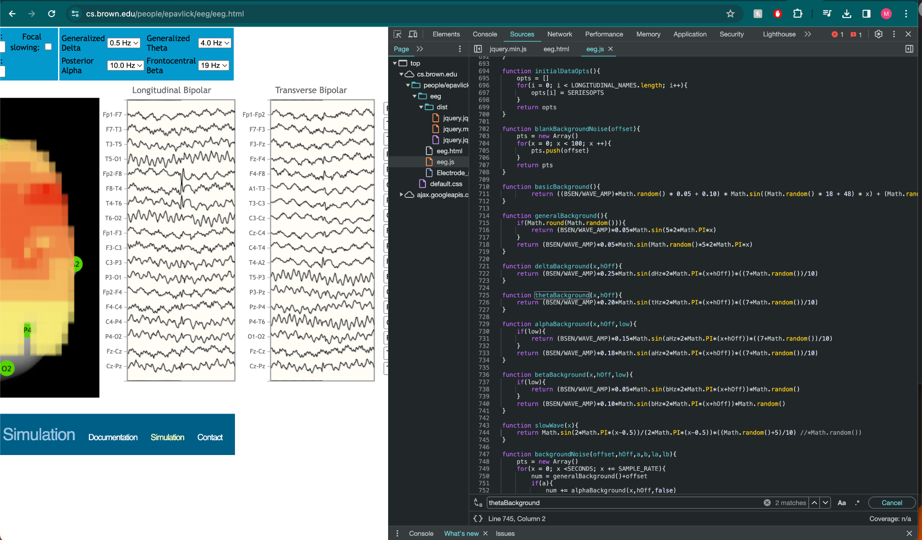

Calculating Dominant Freq from EEG:

* Acquire EEG → perform FFT (Fast Fourier Transform) on the EEG to get the frequency power spectrum → determine dominant frequency from power spectrum
* During treatment application, the dominant frequency is recalculated every 1/16 second based on the last 16 measurements
* Dominant frequency = the mean of all of the frequencies in the power spectrum (typically 0-35 Hz → this range captures all 4 types of waves you’d see in a EEG)
* Treatment application is then adding 5Hz to this frequency value every 1/16 second and delivering it, so if the dom freq was 15, it would start with 20, 25, 30, 35…
* Typical therapeutic effect would be a decrease in the amplitude of the delta wave specifically

GPT Info:

**wtf is Dominant Frequency**

Yes, the dominant frequency in the context of EEG (electroencephalography) recordings and power spectrums refers to the frequency band or specific frequency that shows the greatest amount of activity or power within a given segment of the EEG data. EEG recordings capture the electrical activity of the brain via electrodes placed on the scalp, and this activity is often analyzed in the frequency domain to better understand various brain states or diagnose conditions.

When EEG data is transformed into the frequency domain (using techniques like Fourier transform), it results in a power spectrum that displays the power (or amplitude squared) of the different frequency components present in the signal. The power spectrum is a way of showing how the power of the signal is distributed across different frequencies.

The dominant frequency is important because:

1. **It can indicate the predominant brain state**: Different frequency bands are associated with different brain states. For example, alpha waves (8-13 Hz) are associated with relaxed, wakeful states, while delta waves (1-4 Hz) are predominant during deep sleep. The dominant frequency can thus provide insight into the subject's state of consciousness or alertness.

2. **It may reveal abnormalities**: Deviations from the typical dominant frequency patterns can indicate neurological issues or abnormalities. For example, a dominance of theta waves (4-8 Hz) in adults during wakefulness might suggest brain dysfunction or other issues.

3. **It can be used in brain-computer interfaces (BCIs)**: Identifying and utilizing the dominant frequency can help in developing BCIs, as it can be a reliable indicator of specific cognitive states or intentions.

4. **Clinical and research applications**: In clinical diagnostics and research, analyzing the dominant frequency can help in the assessment of neurological health, the effect of interventions, or the progression of diseases affecting brain function.

It's worth noting that the "dominant" frequency is not always singular; multiple dominant frequencies can exist across different brain regions or times, reflecting the complex and dynamic nature of brain activity.

**Calculating Dom Freq from EEG data:**

Calculating the dominant frequency from EEG data involves a few steps, primarily focusing on converting the time-domain signal (your EEG data) into the frequency domain to identify the frequency with the highest power. This is typically done using the Fast Fourier Transform (FFT), which efficiently computes the Discrete Fourier Transform (DFT) of a sequence. The process can be summarized as follows:

1. **Preprocessing**: Before applying FFT, it's often beneficial to preprocess the EEG data. This might include filtering to remove noise (e.g., using a band-pass filter to retain frequencies of interest while excluding noise and artifacts) and windowing to mitigate edge effects in the FFT.

2. **Applying FFT**: Use FFT on your time-domain EEG data (the (x, y) values, where x is time and y is amplitude) to convert it into the frequency domain. The result will give you a spectrum showing the amplitude (or power) of various frequencies present in the data.

3. **Finding the Dominant Frequency**: Examine the power spectrum to identify the frequency (or frequencies) with the highest amplitude or power. This frequency is considered the dominant frequency.

Here's a basic example of how you could perform these steps in Python using NumPy, assuming `y` contains your EEG signal data sampled at a rate `fs`, and `x` represents time (which isn't directly used in the FFT):

```python

import numpy as np

import matplotlib.pyplot as plt

# Assuming 'y' is your EEG data and 'fs' is the sampling frequency

fs = 250 # Example sampling frequency in Hz

y = np.random.randn(1024) # Example EEG data, replace with your actual data

# Apply FFT to convert the signal from time domain to frequency domain

Y = np.fft.fft(y)

freqs = np.fft.fftfreq(len(y), 1/fs)

# Compute the power spectrum

power = np.abs(Y)**2

# Find the dominant frequency

dominant_freq = freqs[np.argmax(power)]

# Plot the power spectrum

plt.plot(freqs[:len(freqs)//2], power[:len(power)//2]) # Plotting only the positive frequencies

plt.xlabel('Frequency (Hz)')

plt.ylabel('Power')

plt.title('Power Spectrum')

plt.show()

print( f'Dominant Frequency: {dominant_freq} Hz')

```

This code snippet demonstrates the basic process: preprocessing isn't included here, but depending on your data, you may need to apply filtering or other cleaning steps before the FFT. The `np.fft.fftfreq` function generates the frequency bins for the given sample length and sampling rate, which is necessary for identifying the actual frequency values in the spectrum. Remember, the power spectrum and the position of the dominant frequency can give you insights into the brain's state during the EEG recording.

**Example of Raw EEG Data**

Here's a plot of simulated EEG data, designed to mimic what you might encounter in a real dataset. This example simulates a signal comprising two frequencies: 10Hz and 20Hz, mixed with some random noise to imitate the complexity of actual EEG recordings. The data is sampled at 250Hz over 10 seconds, though the plot is zoomed in to show just the first 2 seconds for clarity.

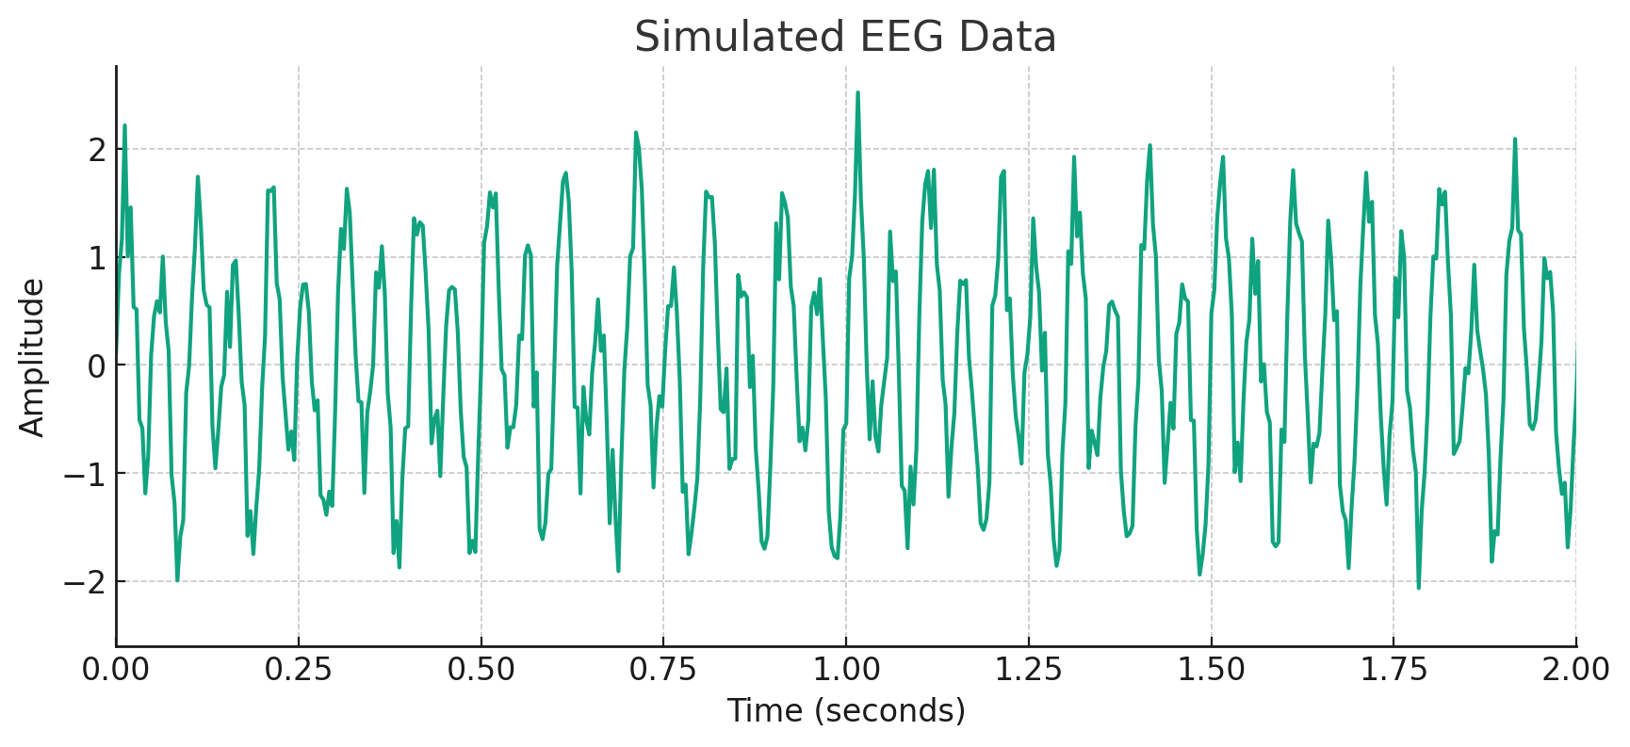

To apply the FFT algorithm and find the dominant frequency in this data, you would feed an array similar to the one shown here into the algorithm:

```

[ 0.12100463, 0.8430842 , 1.166777 , 2.21517232, 1.00251697,

1.45665337, 0.53475715, 0.51270157, -0.507903 , -0.58682553, ...]

```

This array represents the amplitudes of the EEG signal at different times (your `y` values). Given this data, the FFT would transform it into the frequency domain, allowing you to identify the dominant frequencies, which in this simulated example would ideally be around 10Hz and 20Hz, plus any contributions from the noise.